Citizenship

# Step-by-step instructions

**Note:** all of these activities are interchangeable and feel free to make changes as necessary.

**Bell Ringers / warm-ups –** (10 – 20 minutes):

Option A: Writing – lesson anticipation:

Ask students to write **3 to 5 sentences** answering the following questions: *“Who is a citizen of the United States? How does someone become a US citizen? What makes someone a ‘good citizen?’”* Ask for volunteers to **read** their answers **aloud**. This a good time to define citizen and to have students copy down the benchmark you will be covering.

Option B: Smartboard Matching:

Project the included PowerPoint slide titled *Citizenship Smartboard Matching*. If you have a Promethean Board import the slide as an “object” which makes it easier to manipulate the slide. Ask students to **complete matching in their notes**. Remind them that these will be new words to them and that they should use context clues to guess the words definitions. When the faster students complete the matching you can **ask students to come up to the smartboard** where they can either **draw a line** from the term to its definition or they can move the definition next to the correct word. Studies show that when students look at the key terms of a section before learning they will be able to anticipate the content they will need to learn. This activity will be repeated later in the lesson.

Option C: Copy down benchmarks and essential questions:- 5 minutes

If you are pressed for time and would like to jump right in you can skip the bell ringer, but be sure to have students **copy down the benchmark and essential questions**. **This should be done for all of the bell ringers.**

**Day 2 Bell Ringer or Class Activity – Read and discuss Oath of Allegiance – 20 minutes**

Write down the text to the Oath of Allegiance either on a white board or smartboard (if you don’t have either, provide the text on paper). Have students rise and raise their right hands. Lead the class in reciting the Oath out loud. Ask the students to right down three things that people taking the Oath promise to do. Call on students to come up and highlight or underline their answers. Make sure that you cover the fact that people promise to **obey the law and Constitution**, stay **loyal** to America and **defend the nation**. [Click here](http://americanhistory.si.edu/citizenship/pdf/LessonPlan_Responsibilities.pdf) for a lesson on the Oath of Allegiance.

**Main Activity: Lecture / Note taking / graphic organizer – 45 minutes to 1 ½ hours:**

Project PowerPoint called *Citizenship PowerPoint*. General strategies throughout:

* **Note taking**: Have students create **2-column notes** with key terms and main ideas in the left and bullet points / definitions in the left. If you have not used 2-column notes [click here](http://www.landmarkoutreach.org/publications/spotlight/two-column-method-note-taking) for an overview and instructions.
* **Reading:** Call on students to read-aloud the text on slides.
* **Call and response:** lead students in a call and response of the key terms. I like to incorporate movements that help describe the content or key terms. For a video of me doing this with my class [click here](https://www.youtube.com/watch?v=fvqCBSnXrfo).
* **Graphic Organizers:** in addition to the smartboard activities we will do laterI recommend doing web diagrams for responsibilities and obligations of citizenship – see below. Graphic organizers allow you to spend extra time on content that they are going to have to memorize and provides that image for their brains.
* **Images / Drawings:** I am a big fan of drawing pictures of important content. Students can add these to their large right hand column of their notes. See below in my graphic organizers.

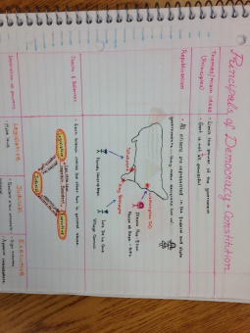

* **Lead by example:** I think it’s important to write the notes you want your students to take on the white board while they are writing it down. There are terms and ideas that you will want them to accentuate and students with language difficulties will appreciate the extra guidance.

**Notes on the content:**

Slides 1 – 7 are pretty self-explanatory

Slide 8 – I have provided a link on the PowerPoint to a PBS Kids article about **illegal immigration**. This is obviously a fairly contentious issue, but this is a good opportunity to open a discussion on the issue. You might provide video excerpts about the issue.

Slide 9 – **Dred Scott** v. Sanford – this used to be required content for my district, however this case is not part of EOC content (but you never know if it will show up.) I usually read the section on page 61 of the McGraw Hill Florida Civics textbook provided by our district. It is important that students are aware that the original **Constitution does not** contain a **definition of citizen** as this will be important to discussing the 14th Amendment.

Slide 10 – you will be teaching the 14th Amendment several times this year. Student must be aware that the **14th Amendment defines citizenship**. You will come back to this when you are teaching the amendments. For pacing reasons I would not discuss the relevance to the end of slavery and the Civil War Amendments (13, 14, 15) at this point but feel free if you would like a

Slides 11, 12, 13, 14 – I would write these as a large graphic separate from 2 column notes, and you might ask students add their own pictures.

Slide 13 – There is a link to a video about “Chinese Birther Tours” – women from China who come to the U.S. to give birth so that their children will be U.S. citizens. This is a debated issue and provides a good opportunity to discuss law of soil.

Slide 15 – have students create this list of **requirements for naturalization** in 2 column notes and then turn it into a web diagram – see below

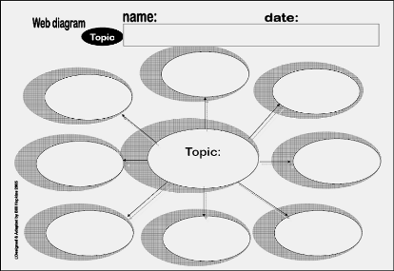

Slide 16 & 17 – Also have students list **steps to naturalization** as bullets and as a flow chart or a sequence graphic organizer. These graphic organizers provide an excellent opportunity to add pictures and allow extra time for students to organize the steps in their heads.

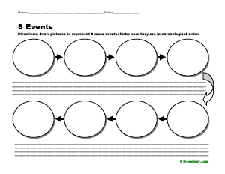

Slides 18 – 26 – As mentioned before web diagrams should be completed for these in addition to listing the **responsibilities and obligations** in their 2-column notes.

Slide 21 – has a link to a video about the draft

**Slides 28 41 – Review:** If you are pressed for time I would recommend having students hold 1 finger up for A 2 for B, etc. However I usually ask students to write down the answers anywhere in their notes or on a scrap piece of paper and I ask two students to come up for each question to walk around the room checking the answers. (I call them my “dingers” and we walk around making loud “dinging” sounds if the kids get the questions correct. The kids love it.)

**Review – Kahoots Video Game (½ hour)** – Note I like to play these a week or two after the lesson as a review.

If you have not checked out Kahoots you have got to right away!! Go to [www.getkahoots.com](http://www.getkahoots.com) and follow instructions. This is an online quiz game and I have made one [here on the Citizenship content](https://play.kahoot.it/#/k/69fab198-cec4-4d83-ad2d-5aed3dfef411) that you can play with your kids. Students will need either a tablet or smartphone to play. You can have kids share a phone or tablet if needed. Check out this video of my kids playing by [clicking here](https://www.youtube.com/watch?v=bRbDMNn4YDo). Kids love these games!!

**Review Smartboard Activity - Matching & T-Chart:**

These can be completed immediately after the lecture / note-taking / graphic organizers or as a Bell Ringer / Warm-up the following class. I sometime like to break of this lesson into several days so as I move onto the next lesson I can back and review previous content.

If you do not have a smartboard use a projector and paper. If you don’t have either print out the PowerPoint slides and make copies.

Instructions: Project the included PowerPoint slide titled *Citizenship Smartboard Matching* and then after *T-Chart Obligations vs. Responsibilities*. If you have a Promethean Board import the slides as an “object” which makes it easier to manipulate the slide. Ask students to **complete matching in their notes**. When the faster students complete the matching you can **ask students to come up to the smartboard** where they can either **draw a line** from the term to its definition or they can move the definition next to the correct word. Or you can wait until everyone finishes so that everyone gets a chance to come up to the smartboard. Kids love writing on the smartboard!!

**Assessment Quiz 1:** I make my students memorize 7 to 10 vocabulary words per week. I would suggest giving a quiz on the key terms

**Assessment Quiz 2:** I have provided a quiz with practice EOC questions. This could also be used as a test

**Homework:** Have students play [*ICivics – Immigration Nation.*](http://www.icivics.org/games/immigration-nation) (15 minutes to 30 minutes.) If you have time play the game on your projector for the students (I usually show them 5 to 10 minutes to get them acquainted with the games.)

Have your students set up an ICivics account at the beginning of the year. Set up different classes for your different periods. Students can log-in and play games for homework and you can check to see if they did their homework. (Note you really have to remind students to write down their user-names and passwords. They will repeatedly forget them. They also need to have an email account and I have been surprised at how few 7th graders have email addresses.)

If you haven’t used ICivic.org you have to check it out. They have a bunch of Civics games that the kids love as well as a wide variety of lesson plans. The lesson plans and PowerPoints are really good and I used to use them a lot more. However, some of them I found to be too time consuming and not exactly on task with the EOC content. They do have good worksheets and packets, but I stopped using them as well. However, I think a lot of teachers do use them and probably have good results.

**Extended activities or additional homework assignments:**

* Have students create a flyer or poster about the Naturalization or Citizenship
* Complete page 60 in McGraw Hill Florida Civics
* Read Dred Scott on page 61 and discuss
* Provide questions for the students to answer from the links with videos about the illegal immigration, law of soil – women who come to the US to give birth, and the draft.
* Have students go through the USCIS – United States Citizenship and Immigration Services website and have them create a quiz to test their neighbors. This can be done as a group assignment as well.